风荷青年
ezpz：
先翻了翻，发现Base64encode，所以直接尝试找加密后的字段，找到

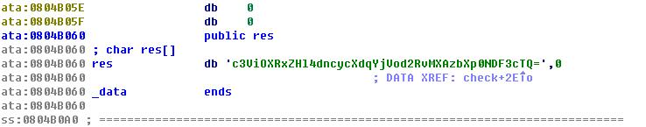
这样，解密完直接得flag

Transformation：

有了ezpz那题的经验，直奔data。
然后就发现了这货
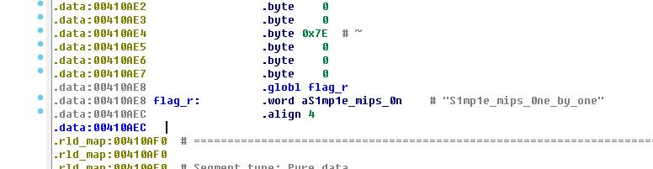
有flag标识结果真是flag

indirect
不得不吐槽一下主办方…这题出错了好吧…
算法是将flag的每一位字母的高、低4位分别作运算，然后和check数组比较，程序出错的地方：
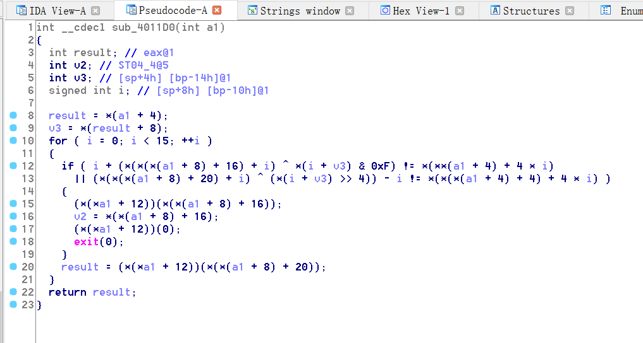
明明应该第一处应该是(*(*(*(a1 + 8) + 16) + i) ^ *(i + v3) & 0xF)-i，
第二处是(*(*(*(a1 + 8) + 20) + i) ^ (*(i + v3) >> 4))+i才对，否则根本无解…
脚本代码如下
s1="sorry,please try again!\n"
s2="Congratulation! you got a right flag!\n"
check1=[0x72,0x65,0x74,0x73,0x74,0x24,0x79,0x67,0x5e,0x5e,0x66,0x5c,0x17,0x6a,0x65]
check2=[0x40,0x6a,0x6b,0x63,0x75,0x6c,0x77,0x79,0x77,0x6f,0x81,0x79,0x74,0x7a,0x30]
flag=""

for i in range(15):
flag_low=(check1[i]+i)^ord(s1[i])
flag_high=(check2[i]-i)^ord(s2[i])
print i
print "flag_low",flag_low
print "flag_high",flag_high
flag += chr(flag_high*16+flag_low)
print flag

Babyfuscator：
很简单的一道题，直接IDA看反编译代码，其实是对输入的32字节flag，每个字节做一些加减异或操作，然后判断与某个整数相不相等，就这样一个一个算出字母。
关键函数sub_400780:
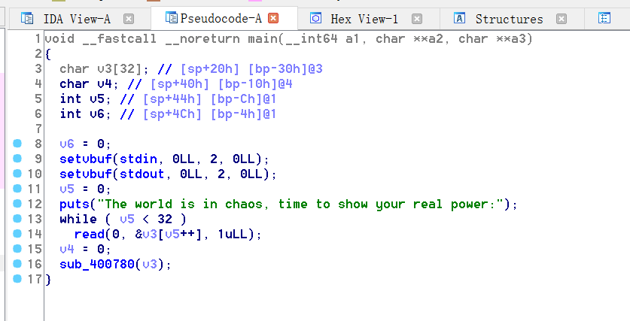

babyandroid
这个题必须吐槽，官方工作效率太低，搞了一个早上才把错误的题目换掉！！！
言归正传，先来看一下代码
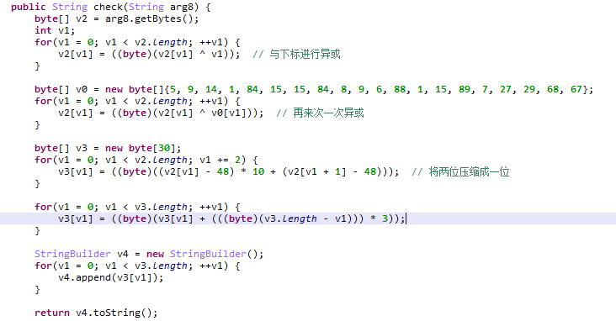
最终生成的结果再来和x-nuca2016进行对比，搜索空间不大，所以直接正向爆破
import string
username = "x-nuca2016"
password = range(20)
#v1 = [5, 9, 14, 1, 84, 15, 15, 84, 8, 9, 6, 88, 1, 15, 89, 7, 27, 29, 68, 67]
v1 = [13, 9, 6, 9, 93, 1, 14, 84, 9, 14, 6, 91, 10, 5, 89, 6, 28, 23, 69, 65]
space = "0123456789abcdef"
solution = [[] for i in range(10)]
for i in range(10):
for c1 in space:
for c2 in space:
c = ((ord(c1) ^ (2*i) ^ v1[2*i]) - 48) * 10
c += (ord(c2) ^ (2*i+1) ^ v1[2*i+1]) - 48

c = c + (10 - i)*3
if c < 256 and c > 0:
tc = chr(c)
else:
tc = "?"
if tc == username[i]:
solution[i].append(c1 + c2)
print solution
flags = solution[0]
for s in solution[1:10]:
tmp_flag = []
for f in flags:
for ss in s:
tmp_flag.append(f + ss)
flags = tmp_flag
for i,f in enumerate(flags):
print i,f

lookatme
同样是一个算法题，仔细分析就可以了
Java部分
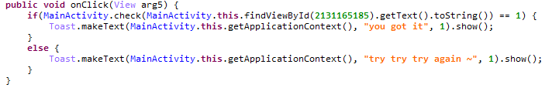
在ida中打开libCrackme，使用check关键字搜索函数
signed int __fastcall Java_oct_rd6_iie_crackme_MainActivity_check(JNIEnv_ *env, int a2, int jstring_flag)
{
_env = env;
v4 = env->functions;
v24 = _stack_chk_guard;
v5 = (const char *)((int (__fastcall *)(JNIEnv_ *, int, _DWORD))v4->GetStringUTFChars)(_env, jstring_flag, 0);
length = j_j_strlen(v5);
if ( length > 14 ) // 长度大于14
{
flag_1 = j_operator new[](20u);
j_j_strcpy((char *)flag_1, v5);
swap(flag_1, (char *)(flag_1 + 8));
swap(flag_1 + 1, (char *)(flag_1 + 3));
swap(flag_1 + 7, (char *)(flag_1 + 2));
swap(flag_1 + 11, (char *)(flag_1 + 3));
swap(flag_1 + 14, (char *)(flag_1 + 9));
swap(flag_1 + 4, (char *)(flag_1 + 10)); // 置换
j_j_memcpy(&dest, &unk_23C4, 0x2Bu);
v8 = j_j_strlen(&dest);
dec(&dest, v8, 0x80u);
fp = j_j_fopen(&dest, (const char *)&unk_2404);// /data/data/oct.rd6.iie.crackme/files/cache
if ( fp )
{
v9 = 0;
byte_1 = 0;
j_j_fread(&byte_1, 3u, 1u, fp);
j_j_fseek(fp, byte_1 ^ 0xFFDC30, 1); // offset = 0x4cf
v19 = 0;
j_j_fread(&v19, 1u, 1u, fp);
do
*(_BYTE *)(flag_1 + v9++) ^= v19;
while ( v9 != length ); // 所有元素与cache的第x个元素异或
if ( check1((char *)flag_1) )
{
jCLass = ((int (__fastcall *)(JNIEnv_ *, const char *))_env->functions->FindClass)(
_env,
"oct/rd6/iie/crackme/CrackmeApp");
jMethod = ((int (__fastcall *)(JNIEnv_ *, int, const char *, const char *))_env->functions->GetStaticMethodID)(
_env,
jCLass,
"onHighMemory",
"(JIB)I");
j_j_memcpy(v21, &unk_23EF, 4u); // 0x3, 0x57, 0x50, 0xe
v22[0] = 0x16156;
v22[1] = 0x1AC29;
v22[2] = 0x185A9;
j = 0;
v22[3] = 0x3C48D;
flag_ptr = flag_1;
while ( 1 )
{
arg1 = (*(_BYTE *)flag_ptr << 24) // 可以确定
+ (*(_BYTE *)(flag_ptr + 1) << 16)
+ (*(_BYTE *)(flag_ptr + 2) << 8)
+ *(_BYTE *)(flag_ptr + 3); // 四个字节拼凑成一个dword
arg2 = v22[j];
arg3 = (unsigned __int8)v21[j];
if ( !_JNIEnv::CallStaticIntMethod(_env, jCLass, jMethod) )
break;
++j;
flag_ptr += 4;
if ( j == 4 ) // 总共进行四轮，所以flag总共16个字节
{
j_j_fread(&byte_1, 1u, 1u, fp);
if ( !sub_8088((char *)flag_1, byte_1) )
break;
j_j_fclose(fp);
result = 1;
goto success;
}
}
}
}
}
result = 0;
success:
if ( v24 != _stack_chk_guard )
j_j___stack_chk_fail(result);
return result;
}
代码中通过反射调用了CrackMeAPP中的onHighMemory函数
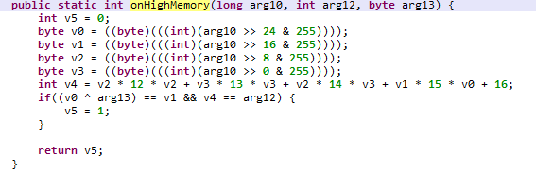
同样，本题比较坑的是在进行交换的时候两次涉及到同一个位置
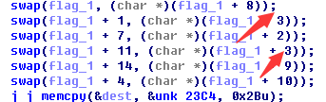
一开始没有注意到浪费了很多去检查代码，好吧，看看代码
import string

arg2 = [0x16156, 0x1AC29, 0x185A9, 0x3C48D]
arg3 = [0x3, 0x57, 0x50, 0xe]

flag1 = [0x0 for i in range(16)]
flag1[0] = 70
flag1[4] = 68
flag1[8] = 18
# flag1[12] <= 65

sums = [] # 12*(v2^2) + 13*(v3^2) + 14*v3*v2
#reverse onHighMemory, 4 bits as a unit
for i in range(3):
v0 = flag1[4*i]
v1 = v0 ^ arg3[i]
sums.append(arg2[i] - 15*v0*v1 - 16)
flag1[4*i+1] = v1

print flag1
print sums

#reverse sub_8088
'''
byte1 = (flag1[3] + byte1) % 128
byte2 = (flag1[7] + byte1) % 128
byte3 = (flag1[11] + byte1) % 128
byte4 = (flag1[15] + byte1) % 128
finally
byte1 = 58
byte2 = 109
byte3 = 105
byte[4] <= 104
'''
bytes_new = [58, 109, 105, 104]
byte1 = 0xa6

for i in range(3):
for v2 in range(256):
for v3 in range(256):
if 12*v2*v2 + 13*v3*v3 + 14*v3*v2 == sums[i]:
byte1_new = (v3 + byte1) % 128
#print v2, v3,byte1_new
if byte1_new == bytes_new[i]:
flag1[4*i+2] = v2
flag1[4*i+3] = v3
print flag1

flag1[12] = []
flag1[13] = []
flag1[14] = []
flag1[15] = []
for v0 in range(66):
v1 = v0 ^ arg3[3]
tsum = arg2[3] - 15*v0*v1 - 16
for v2 in range(256):
for v3 in range(256):
if 12*v2*v2 + 13*v3*v3 + 14*v3*v2 == tsum:
byte1_new = (v3 + byte1) % 128
if byte1_new <= bytes_new[3]:
flag1[12].append(v0)
flag1[13].append(v1)
flag1[14].append(v2)
flag1[15].append(v3)

print flag1

def isChars(flag):
for i in flag:
if i not in '0123456789abcdefghijklmnopqrstuvwxyzABCDEFGHIJKLMNOPQRSTUVWXYZ_':
return False
return True

byte_xor = 0x76
flag2 = []
for i,f in enumerate(flag1):
if i<12:
flag2.append(flag1[i] ^ byte_xor)
else:
tmpL = []
for t in flag1[i]:
tmpL.append(t ^ byte_xor)
flag2.append(tmpL)
#print flag2

def swap(i,j):
tmp = flag2[i]
flag2[i] = flag2[j]
flag2[j] = tmp

swap(0,8)
swap(11,3)
swap(1,3)
swap(7,2)
swap(14,9)
swap(4,10)

# print flag2

for i in range(len(flag1[12])):
flag = ""
for k in flag2:
if type(k) == list:
flag += chr(k[i])
else:
flag += chr(k)
if isChars(flag):
print byte_xor
print flag.encode('hex'),flag

